Chapter 9 Notes - Perimeter, Circumference, and Area

9-1 Perimeter and Circumference
Perimeter is the distance around the outside edge of an object. A Capital “P” is used for the word. To find the perimeter of an object, you add the lengths of each side.
12 cm
P =

6 cm

10 cm

A rectangle’s perimeter is equal twice the length added to twice the width.
P = 2 l + 2 w
P =
5 cm
16 cm

The distance around a circle is called the circumference. The formula for the circumference is equal to the diameter (distance across the circle) times π (pi) a constant number equal to 3.14.
d = 8 cm
C = πd

C = 2πr

r = 4 cm
9-2 Area of Circles
The Area of an object is equal to the length times the width. If a circle is cut into pie slices and rearranged into a rectangle, you find that its width is equal to its radius (r) and the length is equal to ½ its Circumference.

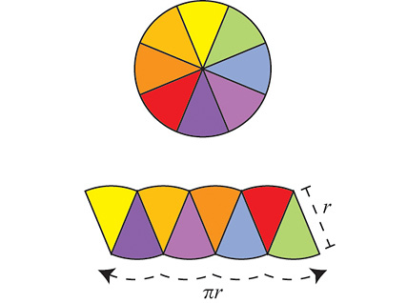

The final formula can be written as:
r = 4 cm
A = πr² = π•r•r
A =

A =
d = 9 cm

9-3 Area of Irregular Figures
A Composite figure is made up of simple geometric shapes like rectangles, triangles, circles, and semi-circles. You can find a composite figure’s area by dividing it up into non-overlapping geometric shapes, and computing each shape’s area, then adding them together.
Ex:
6 cm
+
+
=

5 cm
Area_{circle} (half of it) =

Area_{rectangle} =

Area_{triangle} = (1/2 area of rectangle) =

9-4 Introduction to Three-dimensional Figures
# of  dimensions | 1 | 1 | 2 | 3
name | point | line | plane | solid
example
Ways to measure  (units used) | counting  (number) | Length  (cm) | Perimeter  (cm)  P = w+l+w+l  (cm)  l  w | Surface Area (cm²)  S.A. =  2(l•h)+  2(l•w)+  2(w•h)+  h  l  w
 | coordinates  D4  1 2 3 4 5  F  E  D  C  B  A | Angle  (degrees°) | Area  (cm²)  A= w• l  l  w | Volume  (cm³)  V= w•l•h  = b•h  h  l  w
Three dimensional figures are measured in: length, width, height.
A flat surface on a 3-D figure is called a face, and the line where two faces meet is called an edge. A point where three or more lines meet on a 3-D figure is called a vertex. Polyhedrons are 3-D figures whose faces are all polygons. The face that is used to name the polyhedron is called its base. Prisms are polyhedrons with 2 parallel equal faces. Pyramids are polyhedrons that have one base and rise to a single vertex.
figure | name | figure | name
9-5 Volume of Prisms and Cylinders
The volume of a prism is equal to its base times its height. V = b• h
8 cm

10 cm
12 cm
3 in
15 in
6 cm
6 cm
4 in

The volume of composite figures is equal to the sum of each figure’s volume.
6 cm
10 cm
16 cm
4 cm
10 cm

9-6 Surface Area of Prisms and Cylinders
To calculate the Surface Area of a figure, you first must lay it out flat to show the shape of each side. This flat figure is called a net. You then can add up the area of each shape in the net to find the total Surface Area.

3 in
2 in
8 in

3 cm
5 cm
5 cm
12 cm
8 cm
6 cm
12 cm

